**Jobsheet-3: Javascript**

**Web Design and Programming Courses**

Erwan Majid/08/2i

Link Github: <https://github.com/Majid5654/Semester-3/tree/master/Week3>

* **Practical Section 1: Creating a Javascript Program**

1. Observe what happens to the browser, then record your observations (Question No. 1)

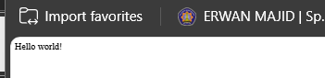

1. Observe what happens in the Console tab, then record your results! (Question No. 2)

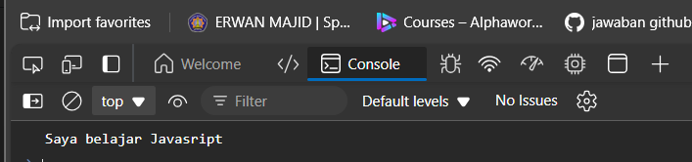

1. Why do you think the command is not displayed? (Question No. 3)

-Because it save in the console.log which it appear in the javascript console,not in the webpage

* **Practical Section 2: How to Write Javascript Code in HTML**

1. Observe what happens to the browser? Record your observations (Question No. 4)



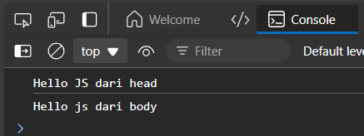

**-**in browser will appear a text tutorial javascript untuk pemula because in script:

<p>Tutorial Javascript untuk pemula</p>

-and if we inspect at choose console,it appear “hello js dari head “ and “Hello js dari body” it because console.log("Hello JS dari head"); console.log("Hello js dari body");just appear when we choose console javascript

1. Which do you think is better, written in the <head> or <body> tag? (Question No.5)

-if I ,prefer in the body,because it easier to read

1. Observe what happens to the browser! Record your observations (Question No. 6)

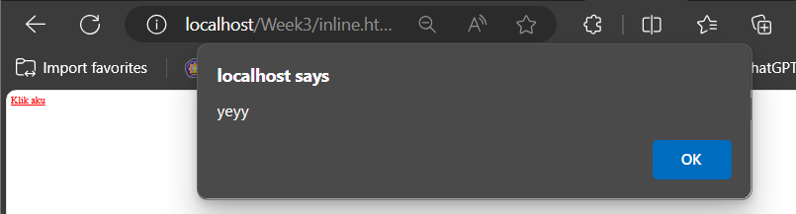

-<a href="#" onclick="alert('yeyy')">Klik aku</a>: This creates a clickable link. When you click the link, it will trigger a JavaScript alert displaying the message "yeyy".

1. What is the difference between the two program codes (Question No. 7)

-if the result is no different ,both same but in the codes   
The onclick attribute defines a JavaScript action that happens when the link is clicked.

The href="#" ensures the link has no navigation behavior (i.e., it doesn't navigate to another page).

1. Observe what happens to the browser! Record your observations (Question No. 8)

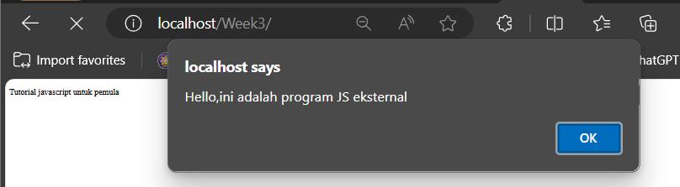

-<script src="kode-program.js"></script>

This line includes an external JavaScript file called kode-program.js which it alert a message “Hello,ini adalah program, JS eksternal”

1. Move kode-program.js file to another folder, what will happen if the javascript file is in a different folder? Observe and record your observations (Question No. 9)

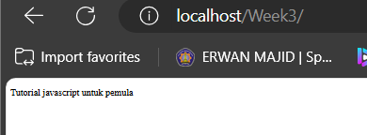

-the external javasript is not working because it locate different folder,it must specific path ,like subfolder/file

* **Practical Section 3: Dialogue Window**

1. Record your observations (Question No. 10)

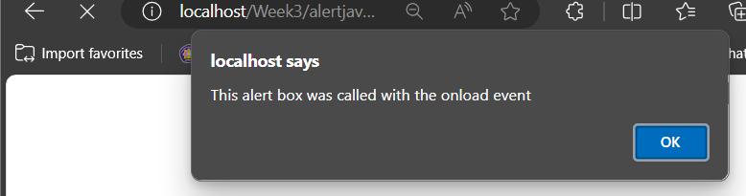

-<script type="text/javascript">:

Defines JavaScript code. The type="text/javascript"

-function message(): Defines a JavaScript function named message.

-alert("This alert box was called with the onload event");: Displays an alert box with the specified message.

<body onload="message()">:

Contains the content of the webpage.

onload="message()": An event handler that executes the message() function when the page finishes loading.

1. Record your observations (Question No. 11)

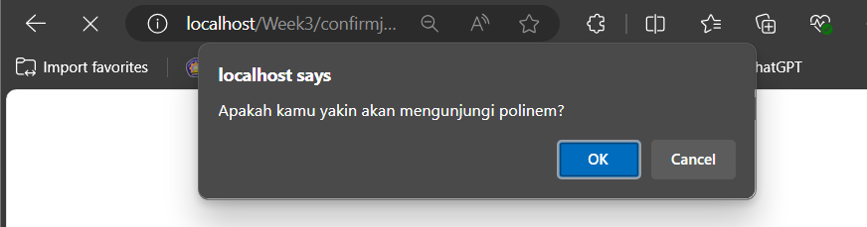

-confirm() Function:

Displays a dialog box with a message ("Apakah kamu yakin akan mengunjungi polinem?") and "OK" and "Cancel" buttons.

Returns true if "OK" is clicked, or false if "Cancel" is clicked.

Conditional Logic:

If true: Redirects the user to the Polinema website (https://www.polinema.ac.id).

If false: Writes "Baiklah, tetapi di sini saja ya" to the document, showing the message on the current page.

The document.write() method will overwrite the entire content of the page if used after the page is loaded.

1. Record your observations (Question No. 12)

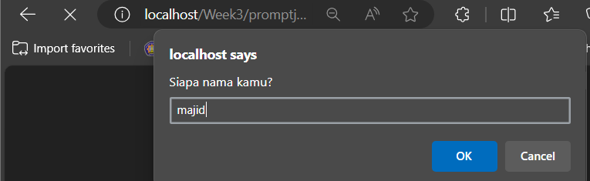

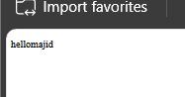

-prompt() Function:

Shows a dialog box asking "Siapa nama kamu?" (What's your name?) with a text input field.

Stores the user's input in the nama variable.

-document.write():

Writes a paragraph (<p>) to the page that says "hello" followed by the user's input

* **Practical Section 4: Variables**

1. Record your observations (Question No. 13)

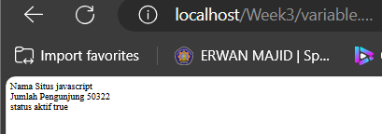

-name stores the string "javascript".

visitorCount stores the number 50322.

isActive stores the boolean value true.

alert():

Displays a pop-up message saying "Selamat datang di javascript".

document.write():

Writes the following declare

"Nama Situs javascript"

"Jumlah Pengunjung 50322"

"status aktif true"

* **Practical Section 5: FUNCTIONS**

1. Record your observations (Question No.14)

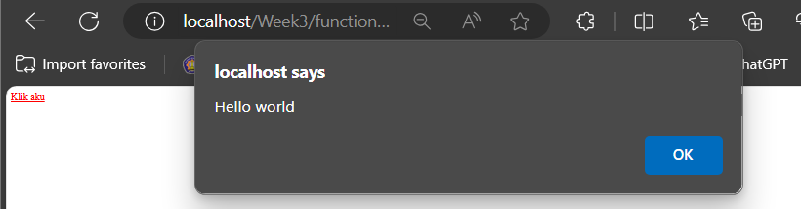

-Arrow Function:

var sayHello = () => alert("Hello world"); defines an arrow function named sayHello.

Arrow functions are a concise syntax for writing functions in JavaScript.

Function Body:

alert("Hello world") is the body of the sayHello function.

It creates a browser alert box that displays the message "Hello world".

Variable Declaration:

var is used to declare the sayHello variable, which holds the function definition.

The function is triggered by clicking the link with the onclick event.

1. Record your observations (Question No.15)

-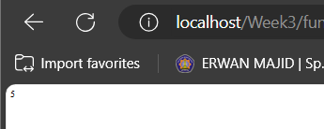

-function total(numberA, numberB): Defines a function named total that takes two parameters, numberA and numberB.

-return numberA + numberB;: Adds the two parameters and returns their sum

-total(2, 3): Calls the total function with 2 and 3 as arguments. The function returns 5 (the sum of 2 and 3).

-document.write(...): Writes the result of the function call directly to the HTML document, so the number 5 is displayed on the web page.

* **Practical Section 6: Data Types**

1. Record your observations (Question No. 16)

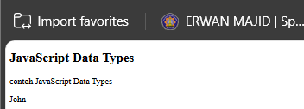

-<p id="demo"></p>:

An empty paragraph element with the id attribute set to "demo". This is where the result will be displayed.

-var x;: Declares a variable x. Initially, x is undefined.

x = 5;: Assigns the value 5 to x. At this point, x holds a number.

x = "John";: Changes the value of x to the string "John". Now, x holds a string.

document.getElementById("demo").innerHTML = x;:

Finds the HTML element with the id "demo".

Sets its innerHTML property to the value of x, which is "John".

1. Record your observations (Question No. 17)

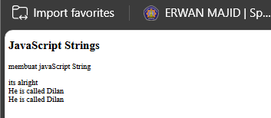

-answer1, answer2, and answer3 are variables storing string values.

-document.getElementById("demo").innerHTML = ...: Sets the HTML content of the element with id="demo".

answer1 + "<br>" + answer2 + "<br>" + answer3: Concatenates the strings stored in the variables with <br> tags for line breaks, so the strings are displayed on separate lines.

1. Record your observations (Question No. 18)

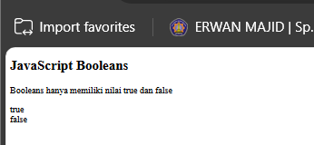

-The id="demo" allows the JavaScript code to locate and modify the specific <p> element with that identifier

-The document.getElementById() method in JavaScript is used to access and manipulate HTML elements by their unique id attribute

-(x == y):

Checks if x is equal to y (which is true since both are 5).

true is displayed as "true" in the HTML.

-(x == z):

Checks if x is equal to z (which is false since 5 is not equal to 6).

false is displayed as "false" in the HTML.

-"<br>":

Adds a line break between the results of the two comparisons

1. Record your observations (Question No. 19)

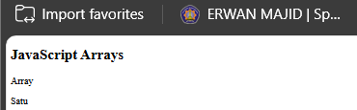

-An empty paragraph (<p id="demo"></p>) serves as a placeholder for displaying the array element

-An array cars is created with three string values: "Satu", "dua", and "Tiga".

-Using document.getElementById("demo").innerHTML, the first item of the cars array (cars[0], which is "Satu") is inserted into the <p> element with the ID "demo."

-When the page is loaded, the word "Satu" will be displayed in the paragraph.

* **Practical Section 7: Operators**

1. Record your observations (Question No.20)

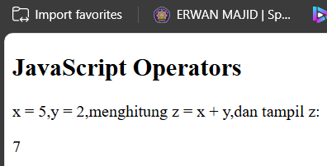

-The document includes a heading (<h2>) and a description (<p>) explaining the operation.

An empty paragraph (<p id="demo"></p>) is used to display the result.

-Two variables x and y are initialized with values 5 and 2.

-A third variable z is calculated as the sum of x + y, which is 7.

-The result (z) is displayed in the paragraph with the ID "demo" using innerHTML

1. Record your observations (Question No. 21)

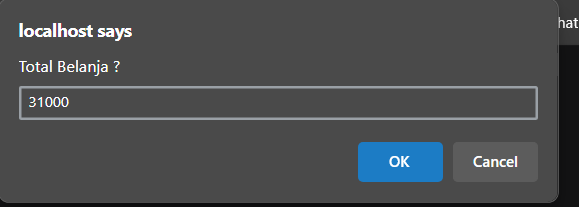

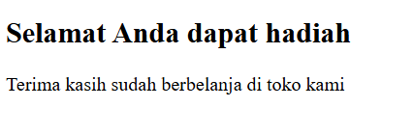

- if (totalBelanja > 30000) so print document.write("<h2> Selamat Anda dapat hadiah </h2>");

}

1. Record your observations (Question No. 22)

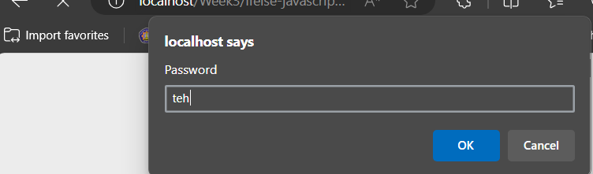

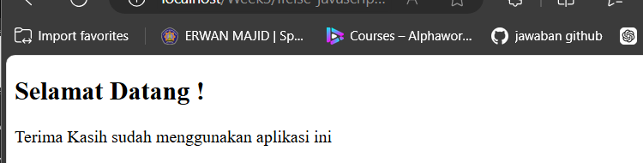

-If the password matches the string "teh", a message saying "Selamat Datang!" (Welcome) is displayed using document.write().

If the password is incorrect, a message saying "Password salah, coba lagi!" (Wrong password, try again) is displayed.

Regardless of the outcome, a final message "Terima Kasih sudah menggunakan aplikasi ini" (Thank you for using this application) is always displayed.

1. Record your observations (Question No. 23)

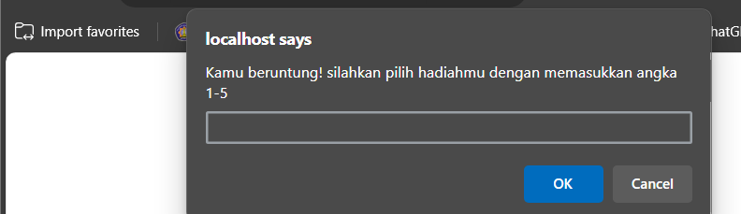

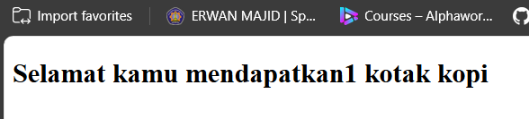

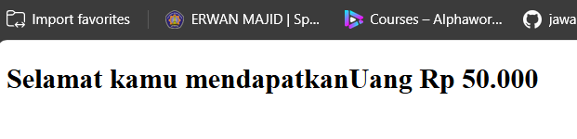

-A switch statement assigns a prize to the variable hadiah based on the user's input. If the input matches a case, the prize is displayed in an <h2> tag. If the input is invalid, an error message is shown. The script also ensures that if no valid prize is selected, it displays a failure message.

1. Record your observations (Question No.24)

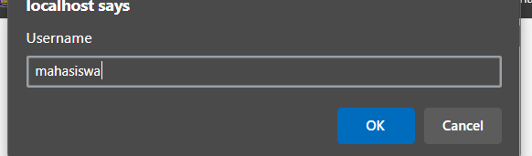

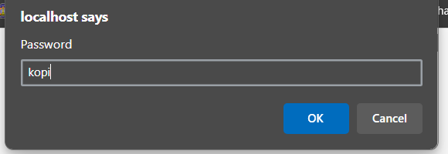

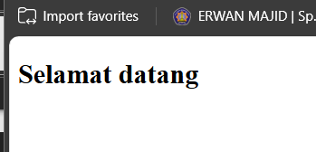

-if username is not mahasiswa:

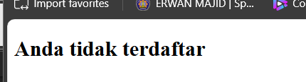

-if username is mahasiswa and the password is wrong:

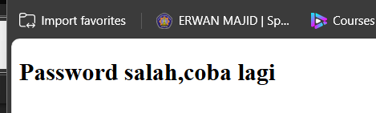

-If the username is "mahasiswa" and the password is "kopi", a welcome message is shown. If the username is correct but the password is wrong, it shows a "wrong password" message. If the username doesn't match, it displays a message saying the user is not registered. The logic is handled with nested if statements.

1. Record your observations (Question No. 25)

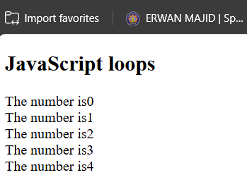

-The loop runs 5 times, starting from i = 0 and incrementing i by 1 each time, stopping when i reaches 5. In each iteration, it adds the phrase "The number is" followed by the current value of i and a line break (<br>).

After the loop finishes, the content of the text variable is inserted into the HTML element with the id="demo" using document.getElementById("demo").innerHTML

1. Record your observations (Question No. 26)

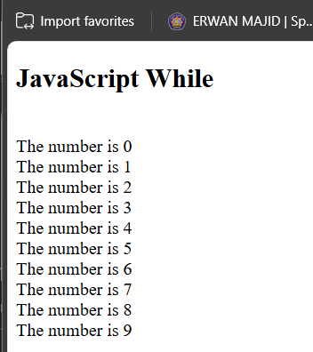

-This script uses a while loop to repeatedly append text to the text variable as long as i is less than 10. Each iteration adds the phrase "The number is" followed by the current value of i and a line break (<br>). The variable i is incremented by 1 in each loop iteration.

Once the loop finishes, the content of text is inserted into the HTML element with id="demo", displaying the numbers from 0 to 9

1. Record your observations (Question No.27)

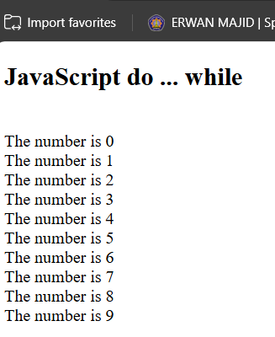

-

This script uses a do...while loop to append text to the text variable. The loop first runs the code inside the do block (adding the phrase "The number is" followed by the current value of i and a line break) before checking the condition. It increments i by 1 and repeats this process as long as i is less than 10.

After the loop finishes, the content of text is inserted into the HTML element with id="demo", displaying numbers from 0 to 9 .